

**TECHNICAL UNIVERSITY OF MOMBASA**

**FACULTY OF MECHANICAL AND AUTOMOTIVE ENGINEERING**

**DEPARTMENT OF MECHANICAL AND AUTOMOTIVE ENGINEERING**

**BACHELOR OF SCIENCE IN MECHANICAL ENGINEERING**

**PROJECT TITLE**

**ANALYSIS AND VERIFICATION OF DEFLECTION OF BEAMS ONE END FIXED AND ONE END PROPPED WITH LOADINGS IN THE FORM OF POINT LOADS, DISTRIBUTED LOADS AND COUPLE LOADS.**

**BY:**

EMMANUEL KIPKORIR BSME/111J/2017

CHARMAINE CHELANGAT BSME/121J/2017

PROJECT SUPERVISOR PROF. MUTULI

A project submitted to the department of mechanical and Automotive Engineering in partial fulfillment of the award of the degree of Bachelor of Science in Mechanical Engineering.

**DECLARATION**

We hereby declare that this project is our original work and has never been presented in this institution or elsewhere for an award of any kind.

EMMANUEL KIPKORIR

BSME/111J/2017

SIGNATURE……………………………… DATE……………………….

CHARMAINE CHELANGAT

BSME/121J/2017

SIGNATURE………………………… DATE…………………………

**THE SUPERVISOR**

I hereby declare that I supervised the above students’ project, it is genuine and submitted under my approval.

PROF. STEPHEN MUTULI

SIGNATURE…………………………… DATE…………………….

DECEMBER 2022

**ACKNOWLEDGEMENT**

We thank the Almighty God for enabling us to undertake this project successfully. We are grateful for good health throughout the entire period of the project.

Our sincere gratitude goes to PROF. MUTULI for his continuous guidance and support. It is through his great efforts that we were able to accomplish this project. The topic is solid and structural mechanics where he is our lecturer.

We would also like to express our acknowledgement to the department of mechanical and automotive engineering for allowing us to use the laboratory at any time we required to perform the experiments. We cannot forget Mr Sudi and Mr Mwafondo for their endless support in the laboratory.

We thank our families for their unlimited support both financially and morally. They played a vital role in ensuring the project comes out successfully.

**DEDICATION**

We dedicate this project to students of The Technical University of Mombasa with an interest of understanding the Analysis of Beams with one end fixed and one end propped in the study of Statically Indeterminate Beams of Solids and Structural Mechanics.

**ABSTRACT**

The main aim of this project was to analyze and verify the deflection of beams that are propped on one end and fixed on the other end. Experimental values were therefore compared to the theoretical values.

A universal testing rig was used for this experiment. It was used to provide support to the steel bar being loaded. A thin, flat, mild steel of uniform cross section was employed to allow easily noticeable deflections when the beam is subjected to relatively small weights of 50 grammes difference. The uniformly distributed loading (UDL) was achieved by using a chopped bar soap (cut into equal sizes of different weights) to ensure that load follows the profile of the beam when it deflects.

Deflection equations at the center of the beam and quarter way and three-quarter way were generated using Macaulay’s method and used in determining the theoretical values of deflection. The theoretical values were then compared with the actual values recorded by a dial gauge indicator (DTI).

CONTENTS

**DECLARATION………………………………………………………………………………………………………………2**

**ACKOWLEDGMENT………………………………………………………………………………………………………3**

**DEDICATION…………………………………………………………………………………………………………………4**

**ABSTRACT……………………………………………………………………………………………………………………5**

**LIST OF TABLES…………………………………………………………………………………………………………….9**

**LIST OF FIGURES………………………………………………………………………………………………………….10**

**ABBREVIATIONS………………………………………………………………………………………………………….11**

**CHAPTER ONE…………………………………………………………………………………………………………….. 12**

**INTRODUCTION………………………………………………………………………………………………………….. 12**

**1.1 Problem statement………………………………………………………………………………………………. 12**

**1.2 Objectives……………………………………………………………………………………………………………. 12**

**1.3 Hypothesis…………………………………………………………………………………………………………… 12**

**1.4 Assumptions……………………………………………………………………………………………………….. 13**

**CHAPTER TWO………………………………………………………………………………………………………….. 14**

**2.0 LITERATURE REVIEW……………………………………………………………………………………………. 14**

**2.1 SIGN CONVENTIONS……………………………………………………………………………………………. 16**

**2.2 METHODS OF ANALYSIS………………………………………………………………………………………. 16**

**2.2.1 Double integration…………………………………………………………………………………………… 16**

**2.2.2 Macaulay’s method…………………………………………………………………………………………. 16**

**2.3 Definition of loads………………………………………………………………………………………………. 17**

**2.3.1 Couple or bending Moment (M) ……………………………………………………………………… 17**

**2.3.2 Point loads (P)…………………………………………………………………………………………………. 18**

**2.3.3 Shear force (V)…………………………………………………………………………………………………. 18**

**2.3.4 Uniformly distributed load (w N/m) ……………………………………………………………….. 18**

**2.3.5 Pure load (Pe)…………………………………………………………………………………………………. 18**

**CHAPTER THREE………………………………………………………………………………………………………. 19**

**3.0 METHODOLOGY…………………………………………………………………………………………………. 19**

**3.1.0 Design of the rig structure…………………………………………………………………………………19**

**3.1.1 Design of the beam specimen………………………………………………………………………19**

**3.1.2 Design and modification of the loading fixture……………………………………………..19**

**3.1.3 Assembling the rig………………………………………………………………………………………. 21**

**3.2 End conditions…………………………………………………………………………………………………21**

**3.2.1 Determining of Young’s Modulus of Elasticity…………………………………………….. 22**

**3.3 Experimental set up………………………………………………………………………………………..24**

**3.4 Sample derivation deflection equation……………………………………………………………25**

**CHAPTER FOUR…………………………………………………………………………………………………….29**

**4.1 RESULTS AND ANALYSIS………………………………………………………………………………….29**

**4.1.1 results for determination of Young’s Modulus of Elasticity……………………………29**

**4.1.2 Simply supported beam…………………………………………………………………………………29**

**4.1.3 Both ends fixed beam…………………………………………………………………………………….30**

**4.1.4 Resultant Young’s Modulus of Elasticity………………………………………………………….31**

**4.2 EXPERIMENTAL RESULT ANALYSIS…………………………………………………………………….32**

**4.2.1 Experiment 1………………………………………………………………………………………………….32**

**4.2.2 Experiment 2…………………………………………………………………………………………………..34**

**4.2.3 Experiment 3………………………………………………………………………………………………….36**

**4.2.4 Experiment 4………………………………………………………………………………………………….38**

**4.2.5 experiment 5…………………………………………………………………………………………………40**

**4.3 DISCUSSION OF RESULTS …………………………………………………………………………………….42**

**4.4 SOURCES OF ERRORS……………………………………………………………………………………………..42**

**CHAPTER FIVE…………………………………………………………………………………………………………43**

**5.0 CONCLUSION……………………………………………………………………………………………………43**

**5.1 RECOMMENDATIONS……………………………………………………………………………………….43**

**5.2 REFERENCES…………………………………………………………………………………………………….44**

**APPENDIX………………………………………………………………………………………………………………45**

**LABORATORY MANUAL…………………………………………………………………………………………….45**

**TITLE……………………………………………………………………………………………………………………….45**

**Objectives ……………………………………………………………………………………………………………..45**

**Apparatus ……………………………………………………………………………………………………………..45**

**Theory……………………………………………………………………………………………………………………45**

**Procedure and experimental set up……………………………………………………………………….45**

**LIST OF TABLES**

Table 1: tabulated deflection results for a simply supported beam.

Table 2: tabulated deflection results for both ends fixed.

Table 3: tabulated results for experiment 1 at x = l/4

Table 4: tabulated results for experiment 1 at x = l/2

Table 5: tabulated results for experiment 1 at x = 3/4l

Table 6: tabulated results for experiment 2 at x = l/4

Table 7: tabulated results for experiment 2 at x = l/2

Table 8: tabulated results for experiment 2 at x = 3/4l

Table 9: tabulated results for experiment 3 at x = l/4

Table 10: tabulated results for experiment 3 at x = l/2

Table 11: tabulated results for experiment 3 at x = 3/4l

Table 12: tabulated results for experiment 4 at x = l/4

Table 13: tabulated results for experiment 4 at x = l/2

Table 14: tabulated results for experiment 4 at x = 3/4l

Table 15: tabulated results for experiment 5 at x = l/4

Table 16: tabulated results for experiment 5 at x = l/2

Table 17: tabulated results for experiment 5 at x = 3/4l

**LIST OF FIGURES**

Figure 1: longitudinal and principal centroidal axes for a straight beam.

Figure 2: displacement of the longitudinal axis of the beam.

Figure 3: distributed load which does not extend to the right.

Figure 4: superposition of loadings which cancel each other.

Figure 5: drawing of a couple fixture.

Figure 6: a sample of the fabricated couple attachment.

Figure 7: universal testing rig.

Figure 8: universal testing rig carrying a simply supported beam.

Figure 9: universal testing rig carrying a beam with both ends fixed.

Figure 10: one end fixed, one end propped beam carrying UDL, couple.

Figure 11: a picture of the experimental set up.

Figure 12: a graph of load against deflection for a simply supported beam.

Figure 13: a graph of load against deflection for a beam with both ends fixed.

Figure 14: a set up for experiment 1.

Figure 15: a set up for experiment 2.

Figure 16: a set up for experiment 3.

Figure 17: a set up for experiment 4.

Figure 18: a set up for experiment 5.

**ABBREVIATIONS**

UDL- uniformly distributed loads

DTI- dial gauge indicator

E- Young’s Modulus of Elasticity

L- length

E- eccentricity

Y- deflection of the beam

P- point load

W- weight per meter run

**CHAPTER ONE**

**1.0 INTRODUCTION**

A beam is a structural member subjected to principally transverse gravity or vertical loading. Deflection is the movement of a beam or node from its original position. It happens due to the forces and loads being applied to it.it can also be referred to as displacement which occurs from externally applied loads or from weights of the body structure itself.

Deflections of a statically determinate structure is one that is stable and all unknown reactive forces can be determined from the equations of equilibrium alone, some of these beams being simply supported beams, cantilever beams, single and double overhanging beams, three hinged arches. A statically indeterminate structure is one that is stable but contains more unknown forces than available equations of equilibrium. These are beams with point loads. Uniformly distributed loads (UDL) and pure couples. The deflections are thus calculated with methods such as direct integration and Macaulay’s method amongst others.

**1.1 PROBLEM STATEMENT**

Previously, simple laboratory experiments have been done to analyze deflection of these beams. They had fabricated a simple rig, incorporated pure couples along the beam without introducing point loads, from readily available materials. They also had found a way to fabricate couple attachments that would introduce eccentric loading to the experiments.

Hence, we were tasked to experiment on various kind of loadings, with the different set ups under the same conditions previously used to verify if the conditions make sense.

**1.2 OBJECTIVES**

* To ensure that any repairs or maintenance work is done on the existing rig.
* To fabricate the couple attachments that will introduce eccentric loading.
* To find and prepare beams that will be required for the experiment.
* To experiment on the deflection of beams with one end fixed and one end propped using point loads, uniformly distributed loads (UDL) and pure couples.
* To compare the theoretical and experimental values.

**1.3 HYPOTHESIS**

* Thinner beams produce easily noticeable deflections.
* Adding metal-bar parking at clamps on the fixed ends helps to achieve end conditions

**1.5 ASSUMPTIONS**

* The beam is straight before loading, no imperfections.
* The stress-strain relationship is linear and elastic.
* The beam material is homogenous and isotropic.
* The beam is of uniform cross section Area.
* Temperature changes in the beam produce stresses and deflections that are negligible.

**CHAPTER TWO**

**2.0 LITERATURE REVIEW**

A straight beam of uniform cross section, when subjected to end couples M applied about a principal axis, bends into a circular arc radius R, given by

…………………………………………………………… (1)

Where EI, which is the product of Young’s Modulus E and the second moment of area I about the relevant principal axis, is the flexural stiffness of the beam, equation () holds only for elastic bending.

Where a beam is subjected to shearing forces, as well as bending moments, the axis of the beam is no longer bent to a circular arc. To deal with this type of problem, we assume that equation (1) still defines the radius of curvature at any point of the beam where the bending moment is M. this implies that where the bending moment varies from one section of the beam to another, the radius of curvature also varies from section to section, in accordance with equation (1).

In the unstrained condition of the beam, Cz is the longitudinal centroidal axis, figure and Cx, Cy are the principal axes in the cross-section. The coordinate axes Cx, Cy are so arranged that the y-axis is vertically downwards. This is convenient as most practical loading conditions give rise to vertically downwards deflections. Suppose bending moments are applied about axes parallel to Cx, so that bending is restricted to the yz-plane, because Cx and Cy are principal axes.

c

x Z

y

Figure 1: longitudinal and principal centroidal axes for a straight beam.

C d f z

y

Figure 2: displacement of the longitudinal axis of the beam

Consider a short length of the unstrained beam, corresponding with DF on the axis Cz, figure .in the strained condition D and F are displaced to D’ and F’ respectively, which lies in the yz-plane. Any point such as D on the axis Cz is displaced by an amount v parallel to Cy, it is also displaced a small, but negligible, amount parallel to Cz.

The radius of curvature R at any section of the beam is given by

…………………………………………………………………………………… (2)

We are concerned generally with only small deflections, in which v is a small, this implies that(dv/dz) is small, and that (dv/dz)2  is negligible compared with unity. Then, with sufficient accuracy, we may write

…………………………………………………………………………………………………………..…. (3)

The equations and give

EI=M ………………………………………………………………………………………… (4)

Adopting the sign conventions,

EI= -M ………………………………………………………………………………………… (5)

(John case (1999) page 295)

**2.1 SIGN CONVENTIONS**

The sign conventions for bending moments and shearing forces to be used in succeeding equations are;

1. The x and y axes are positive to the right and upward respectively.
2. The deflection y is positive upward.
3. The bending moments M is positive when it produces compression in the upper part of the beam.
4. The slope and the angle of rotation Ө are positive when counterclockwise with respect to the positive x-axis.
5. The bending moment M is positive when it produces compression in the upper part of the beam.

(Goodno, 2009) page 682

**2.2 METHODS OF ANALYSIS**

In the analysis of beams three methods were used;

**2.2.1 DOUBLE INTEGRATION METHOD**

The first integration is of equation (5) and this gives the slope of the beam and a distance x-along its length when the origin is taken from the left end. Therefore

………………………………………………………………………..………………………… (6)

The second integration gives the deflection of the beam at the above point or

……………………………………………………………………. (7)

c and c1 constants of integration, can be evaluated from the unknown conditions of the slope and deflection at certain points, usually at the supports.

(Crawford ,1987) page 174

**2.2.2 MACAULAY’S METHOD**

This approach requires one bending moment expression to be written down for appoint close to the right-hand end to cover the bending moment conditions for the whole length of the beam; hence on integration only two unknown constants have to be determined. The step function is a function of x of the form such that for x < a , and for x > a , . Note that the change in the form of brackets used, the square brackets are particularly chosen to indicate the use of step functions; the curved brackets representing normal mathematical procedures. The important features when using the step function in analysis ate that, if any substitution of a value for x the quantity inside becomes negative, it is omitted from further analysis. Square bracket terms must be integrated in such a way as to preserve the identity of the bracket that is

Also, for mathematically continuity, distributed load which does not extend to the right-hand end as in figure 3, must be arranged to continue to x = l whether starting from x = 0 or x = a.

This may be affected by the superposition of the loadings which cancel each other in the required portions of the beams as shown in figure 4.

An applied couple M0 must be expressed as step function in the form so that the brackets can be integrated correctly.

(Crawford, 1987) page 178

A B C D

C

Figure 3: distributed load which does not extend to the right

A B C D

Figure 4: superposition of loadings which cancel each other.

**2.3 DEFINITION OF LOADS**

Below are the definitions of loads being used:

2.3.1 BENDING MOMENT (M)

In solid mechanics, a bending moment is the reaction induced in the structural element when an external force or moment is applied to the element, causing the element to bend.

2.3.2 POINT LOAD(P)

Point loads is a force that acts perpendicular to the area. It is developed whenever the external load tends to push or pull on the two segments of the body.

2.3.3 SHEAR FORCE (V)

Shearing forces are unaligned forces pushing one part of a body in one specific direction, and another part of the body in another different direction.

2.3.4 UNIFORMLY DISTRIBUTED LOAD (w N/m)

This is a force that is applied evenly over the distance of a support.

2.3.5 PURE COUPLE (Pe)

This consists of two parallel forces that are equal in magnitude, opposite in sense and do not share a line of action. It does not produce any translation only rotation.

**CHAPTER THREE**

**3.0 METHODOLOGY**

**3.1.0 DESIGN OF THE RIG STRUCTURE**

The rig has three different support frames. The top rectangular frame, several vertical frames and the base frame. Mild steel square tubes of one inch by one-inch square cross section were selected for fabrication of the frames. This material was selected since it could be easily machined by cutting and joined by arc welding during rig fabrication. Two flat bars of 250 mm by 51 mm were spot welded to the ends of rig structure for firm grip of the beam. Metal parking were also incorporated at the points of clumping to achieve fixed end conditions.

**3.1.1 DESIGN OF THE BEAM SPECIMEN**

A beam of 50mm by 29.5mm was chosen. The length of the beam was chosen 1.5 meters so that it fits into the rig structure with reasonable length to offer working length and place for support.

**3.1.2 DESIGN AND MODIFICATION OF THE LOADING FIXTURES**

3.1.2.1 COUPLING FIXTURE

For the couple loads, 2 flat plates were required for each. The plates were drilled at their axis near the ends, fitted onto the beam and fastened with bolts. An L shaped bar with an eccentricity of 150mm is welded to it to introduce an eccentric loading producing a couple and point load.

e

P

beam

Figure 5: drawing of a couple fixture

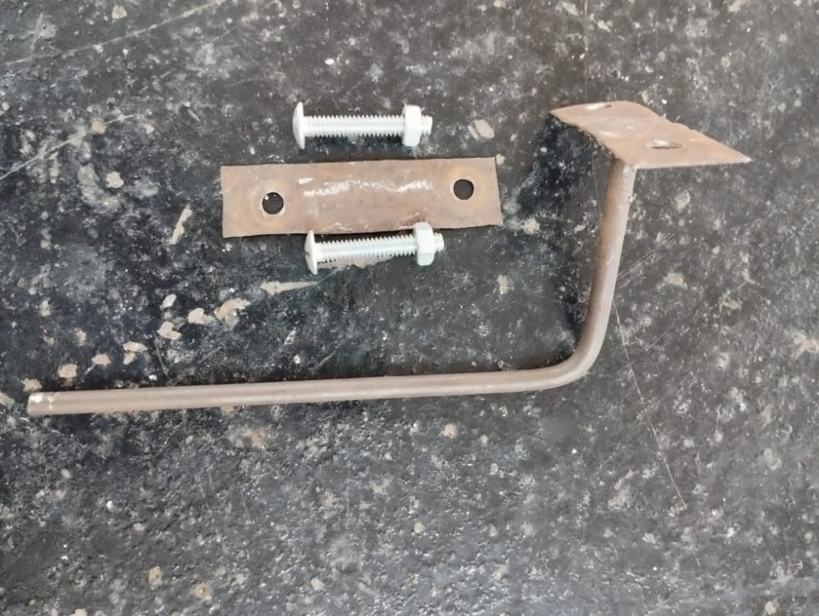

Figure 6: a sample of the fabricated couple attachment.

3.1.3.1 UNIFORMLY DISTIBUTED LOAD FIXTURE

A bar of Msafi soap was used to obtain uniformly distributed load. To get weight per meter run:

1. The length of the bar was measured to be 40.5 cm and of mass 700g.
2. The bar was cut into 10 pieces of 2.5 cm each.
3. The bar soaps were of different weights. They were then added up totally to acquire the total weight required for each loading.
4. The mass of each piece was converted to kilograms.
5. The result was then multiplied by gravitational acceleration of 9.81, to achieve the weight per meter run.

3.1.3.2 PURE COUPLE FIXTURE

a) The couple attachment is loaded eccentrically by a weight ‘P’ which produces a couple ‘Pe’ and a point load ‘P’.

b) A thin frictionless string is tied at the middle of the couple attachment. The string is lubricated to minimize the frictional resistance.

c) The string is passed across a finely smoothened rod (also lubricated by grease) on the top carriage of the testing rig.

d) A load ‘P’ is tied at the end of the string to eliminate the effects of the load ‘P’ loaded eccentrically leaving the pure couple ‘Pe’.

**3.1.3 ASSEMBLING THE RIG**

Different parts were assembled onto the rig structure to correspond to their positions per designed drawing.

The rails were used as the specimen beam support were welded on the main frame of the rig 0.25 of the meters on the opposite sides from the rig axis.

The dial indicator support was arc welded 15 cm from the base of the rig and was 1 meter long made of two rectangular tube bars welded together.

The final rig structure is as in the figure below

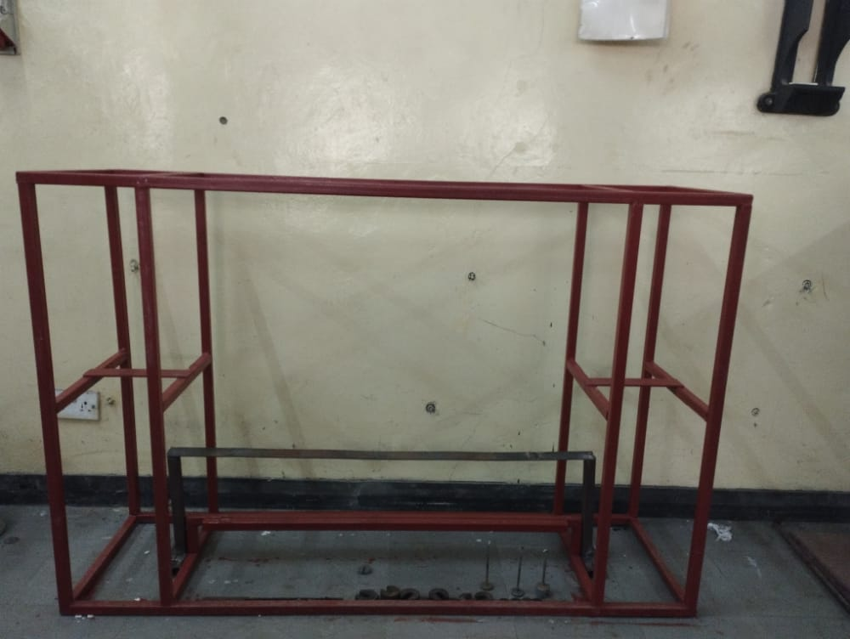

Figure 7: universal testing rig.

**3.2 END CONDITIONS**

3.2.1 DETERMINING OF YOUNG’S MODULUS

The following experiments were done to obtain Young’s Modulus of Elasticity.

1. A simply supported beam loaded at midpoint with a point load and deflection taken at the midpoint.
2. A beam with both ends fixed loaded at the midpoint with a point load and deflection taken at midpoint.

3.2.1.2 DETERMINATION OF YOUNG’S MODULUS OF ELASTICITY OF A SIMPLY SUPPORTED BEAM

a) The beam used was 1 m long.

b) The beam was left to lay freely on the rig.

c) The beam was then loaded at midpoint with point loads from 50 grams to 300 grams. Deflection of every loading was taken at the midpoint of the beam using a dial gauge indicator. Three reading were taken for each loading and the average calculated.

d) A graph of load against deflection was then plotted. The slope of the graph ( was then determined and equated with the equation of deflection of the beam at midpoint y=

e) since I is the second moment of area of the beam, it was easily calculated using the relation also since L was the length of the beam, Young’s Modulus of elasticity E was then finally determined.

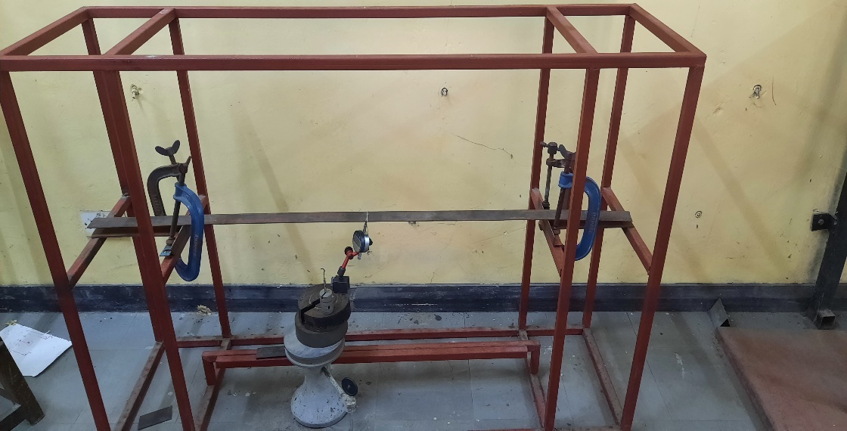

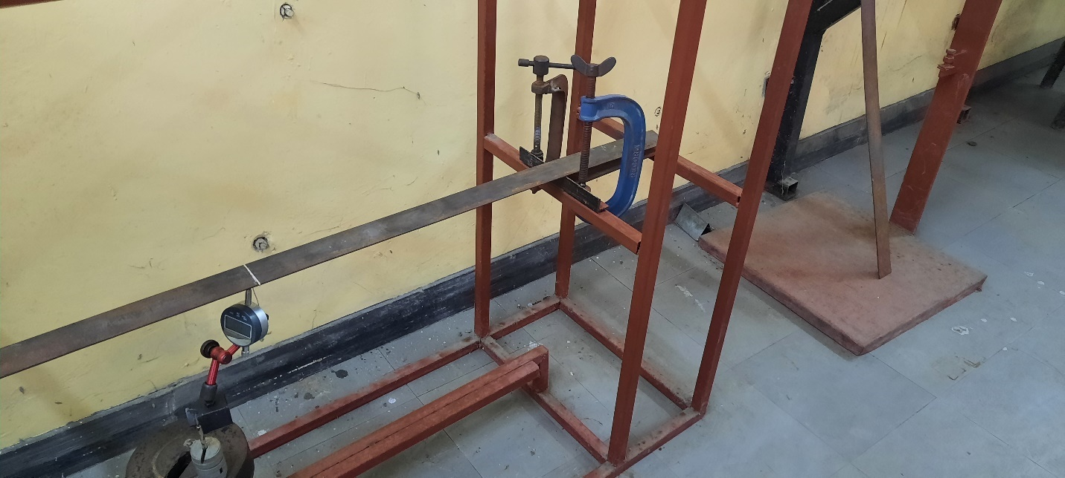

Figure 8: universal testing rig carrying a simply supported beam

3.2.1.3 DETERMINATION OF YOUNG’S MODULUS OF ELASTICITY OF A BEAM FIXED AT BOTH ENDS.

a) The beam used was 1 m long

b) The beam was held firmly by a G clamp at both ends of the beam.

c) The beam was then loaded at midpoint with point loads from 50 grams to 300 grams. Deflection of every loading was taken at the midpoint of the beam using a dial gauge indicator. Three reading were taken for each loading and the average calculated.

d) A graph of load against deflection was then plotted. The slope of the graph ( was then determined and equated with the equation of deflection of the beam at midpoint y=

e) since I is the second moment of area of the beam, it was easily calculated using the relation also since L was the length of the beam, Young’s Modulus of elasticity E was then finally determined.

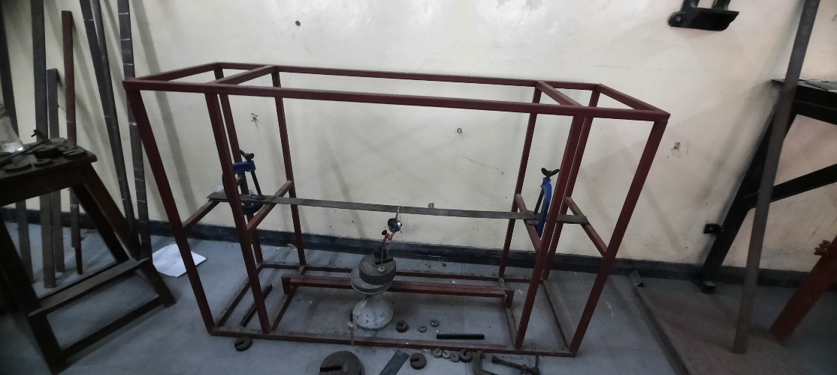

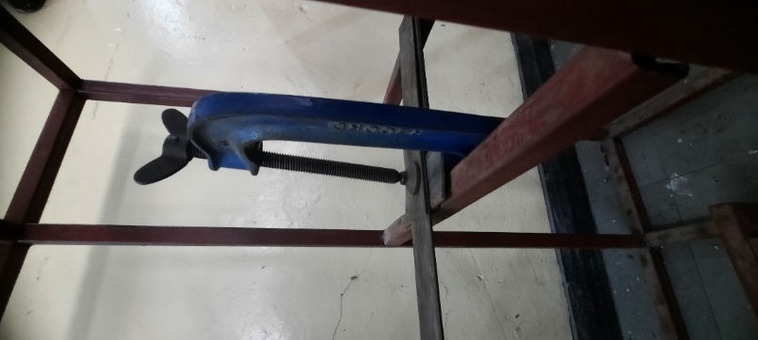

Figure 9: universal testing rig carrying a beam with both fixed ends.

**3.3 EXPERIMENTAL SET UP**

ONE END FIXED AND ONE END PROPPED

The loadings were uniformly distributed, a point load and a pure couple. The length of the beam in this set up was 1m long. The UDL, couple and pure couple fixtures were obtained as described in the previous section. The beam was fixed on the rig structure, with one end fixed with two G-clamps and the other end left to lay on the rig structure. The DTI was then positioned at x= from the left-hand side of the beam and the beam loaded gently with the pieces of soap.

Fixtures for couple and pure couple were then loaded weights of 50g and the deflection recorded. The loadings were increased in steps of 50g up to 300g and three readings recorded under each loading. An average of the three readings under each loading was taken.

The same procedure was followed to derive expressions that were used to calculate deflection at . A comparison between the theoretical deflection and the experimental deflection was then done.

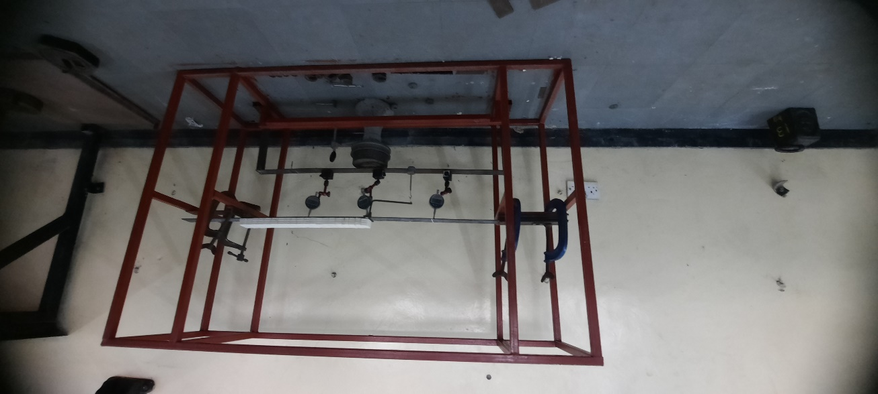

Figure 10: a picture of the experimental set up

**3.4 A SAMPLE DERIVATION DEFLECTION EQUATION**

Beam fixed at the left-hand end and propped at the right-hand end with uniformly distributed load and a couple

P

Pe

l/2

l/2

## Figure 11: one end fixed one end propped carrying UDL, couple

**Equation of forces**

V1 + F = + P………………………………………………………………… (1)

**Equilibrium of moments**

M1 + Pe +Fl =

M1 + Pe + Fl = ……………………………………………………… (2)

.

**Deflection equation**

.

…………………………….. (3)

………………….. (4)

**Boundary conditions**

At x = 0 y = 0

At x = 0 =0

At x = 0 y = 0

**At x = 0, y = 0**

C2 = 0 ……………………………………………………………………………………………………………………………… (5)

**At x = 0, y = 0**

0 = C1 ……………………………………………………………………………………………………………………………………………………………………………………………… (6)

**At x = l, y = 0**

0 =

0 =

0 =

0 =

0 =

M1 = ………………………………………………………………………………………………. (7)

**Eq 1 & 2**

M1 + Pe + l [

M1 + Pe + P + - V1 =

M1 + Pe + – V1l = 0

M1 = V1l- Pe - ………………………………………………………………………………………………. (8)

Eq 7 & 8

= V1l- Pe -

. = + +

V1 = + + …………………………………………………………………………………………………… (9)

**Eq 8**

M1 = V1l- Pe -

M1 = l[ + + ] - Pe -

M1 =  + + - Pe -

M1 =  + + ………………………………………………………………………………………………. (10)

**At x = ¼**

EI

*EI y =*

*EI y =*  + + + + ]

*EI y =*  - - + +

*EI y =*  - -

**At x = ½**

EI

*EI y =*

*EI y =*

*EI y = =*  + + + + ]

*EI y =*  - - + +

EI y = + -

**at x = ¾ l**

EI y =

EI y =

EI y =

EI y =

EI y = + + + + ]

EI y = - - + +

EI y = + -

**CHAPTER 4**

**4.1 RESULTS AND ANALYSIS**

**4.1 RESULTS AND DETERMINATION OF YOUNG’S MODULUS OF ELASTICITY**

4.1.1 SIMPLY SUPPORTED

Table 1: tabulated of deflection results for a simply supported beam

|  |  |  |  |  |  |  |  |
| --- | --- | --- | --- | --- | --- | --- | --- |
| Load(g) | 0 | 50 | 100 | 150 | 200 | 250 | 300 |
| 1st reading (mm) | 0.0 | 0.44 | 0.90 | 1.37 | 1.78 | 2.24 | 2.60 |
| 2nd reading(mm) | 0.0 | 0.37 | 0.87 | 1.34 | 1.76 | 2.17 | 2.66 |
| 3rd reading(mm) | 0.0 | 044 | 0.89 | 1.36 | 1.81 | 2.21 | 2.67 |
| Average (mm) | 0.0 | 0.42 | 0.89 | 1.36 | 1.77 | 2.21 | 2.65 |

A graph of load against deflection

Figure 12: a graph of load against deflection for a simply supported beam

The gradient of the graph was determined and used as shown to calculate Young’s Modulus of Elasticity

Slope =

Slope = 1097.6214 N/m

For the beam specimen selected, b = 50.25 mm and d = 3 mm

Where, I = = =

E =

E = 1097.6214

E = 202.251

GPa

4.1.2 BEAM WITH BOTH ENDS FIXED

Table 2: tabulated results for a beam with ends fixed.

|  |  |  |  |  |  |  |  |
| --- | --- | --- | --- | --- | --- | --- | --- |
| Load (g) | 50 | 100 | 150 | 200 | 250 | 300 | 350 |
| 1 reading (mm) | 0.0 | 0.01 | 0.14 | 0.28 | 0.42 | 0.55 | 0.65 |
| 2 reading (mm) | 0.0 | 0.02 | 0.15 | 0.27 | 0.42 | 0.55 | 0.67 |
| 3 reading (mm) | 0.00 | 0.02 | 0.15 | 0.28 | 0.40 | 0.54 | 0.63 |
| Average (mm) | 0.00 | 0.017 | 0.15 | 0.28 | 0.41 | 0.55 | 0.65 |

Figure 13: A graph of load against deflection for a beam with both ends fixed.

Slope = = 4527.6401 N/m

Where, I = = =

E =

E = 4527.6401 N/m

E

**4.1.3 Resultant Youngs Modulus of Elasticity**

The resultant value of E was obtained by finding the average of the two values of E obtained in the above two experiments.

Average Modulus of Elasticity (E) =GPa + GPa]/2

= 205.412

This value was used in the theoretical calculation of deflection in the experimental set up for one end fixed and one end propped beam.

**4.2 EXPERIMENTAL RESULT ANALYSIS**

**4.2.1 EXPERIMENT 1**

P

Pe

l/2

l/2

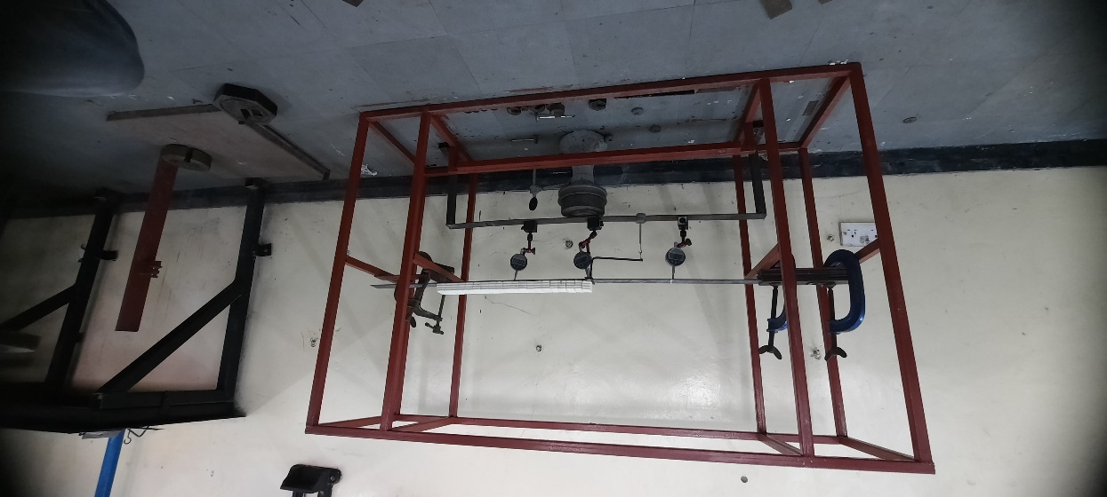

Figure 14: set up for experiment 1

**At x = ¼l**

Y =

Table 3: tabulated results for experiment 1 at x =

|  |  |  |  |  |  |  |  |
| --- | --- | --- | --- | --- | --- | --- | --- |
| Load (g) | 0 | 50 | 100 | 150 | 200 | 250 | 300 |
| 1st reading(mm) | 0.76 | 0.98 | 0.88 | 0.97 | 1.06 | 1.16 | 1.28 |
| 2nd reading(mm) | 0.77 | 0.83 | 0.91 | 0.99 | 1.08 | 1.19 | 1.27 |
| 3rd reading(mm) | 0.78 | 0.84 | 0.91 | 0.99 | 1.09 | 1.18 | 1.30 |
| Average(mm) | 0.77 | 0.88 | 0.90 | 0.98 | 1.08 | 1.18 | 1.28 |
| Theoretical(mm) | 0.92 | 1.01 | 1.10 | 1.19 | 1.28 | 1.37 | 1.46 |
| Deviation | 0.15 | 0.13 | 0.20 | 0.21 | 0.20 | 0.19 | 0.18 |
| % deviation | 16.30 | 12.87 | 18.18 | 17.65 | 15.63 | 13.87 | 12.33 |

**At y = ½l**

]

Table 4: tabulated results for experiment 1 at x =

|  |  |  |  |  |  |  |  |
| --- | --- | --- | --- | --- | --- | --- | --- |
| Load (g) | 0 | 50 | 100 | 150 | 200 | 250 | 300 |
| 1st reading(mm) | 2.24 | 2.27 | 2.40 | 2.53 | 2.68 | 2.88 | 3.09 |
| 2nd reading(mm) | 2.20 | 2.28 | 2.41 | 2.55 | 2.72 | 2.90 | 3.06 |
| 3rd reading(mm) | 2.19 | 2.29 | 2.39 | 2.54 | 2.72 | 2.87 | 3.12 |
| Average(mm) | 2.21 | 2.28 | 2.40 | 2.54 | 2.71 | 2.88 | 3.09 |
| Theoretical(mm) | 2.30 | 2.47 | 2.64 | 2.81 | 2.97 | 3.14 | 3.31 |
| Deviation | 0.09 | 0.19 | 0.24 | 0.27 | 0.26 | 0.26 | 0.22 |
| % deviation | 3.91 | 7.69 | 9.09 | 9.61 | 8.75 | 8.28 | 6.65 |

At y = ¾l

y = ]

Table 5: tabulated results for experiment 1 at x =

|  |  |  |  |  |  |  |  |
| --- | --- | --- | --- | --- | --- | --- | --- |
| Load (g) | 0 | 50 | 100 | 150 | 200 | 250 | 300 |
| 1st reading(mm) | 2.01 | 2.07 | 2.14 | 2.23 | 2.32 | 2.43 | 2.54 |
| 2nd reading(mm) | 2.01 | 2.05 | 2.13 | 2.20 | 2.32 | 2.41 | 2.51 |
| 3rd reading(mm) | 2.04 | 2.05 | 2.12 | 2.21 | 2.30 | 2.41 | 2.52 |
| Average(mm) | 2.02 | 2.06 | 2.13 | 2.21 | 2.31 | 2.42 | 2.52 |
| Theoretical(mm) | 2.16 | 2.27 | 2.38 | 2.49 | 2.59 | 2.70 | 2.81 |
| Deviation | 0.14 | 0.21 | 0.25 | 0.28 | 0.28 | 0.28 | 0.29 |
| % deviation | 6.48 | 9.25 | 10.50 | 11.24 | 10.81 | 10.37 | 10.32 |

**4.2.2 EXPERIMENT 2**

l/3

l/3

l/3

P

P

Pe

Pe

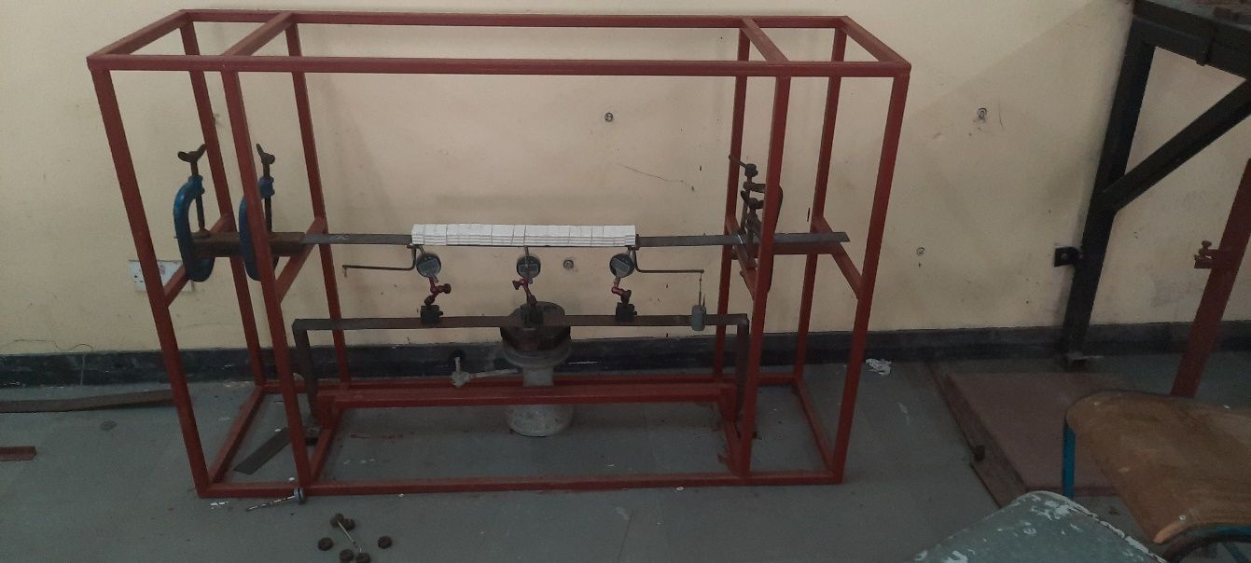

Figure 15: a set up for experiment 2

**At x = ¼ l**

y = ]

Table 6: tabulated results for experiment 2 at x =

|  |  |  |  |  |  |  |  |
| --- | --- | --- | --- | --- | --- | --- | --- |
| Load (g) | 0 | 50 | 100 | 150 | 200 | 250 | 300 |
| 1st reading(mm) | 1.07 | 1.27 | 1.37 | 1.49 | 1.60 | 1.70 | 1.83 |
| 2nd reading(mm) | 1.16 | 1.26 | 1.38 | 1.50 | 1.61 | 1.73 | 1.85 |
| 3rd reading(mm) | 1.16 | 1.25 | 1.39 | 1.50 | 1.57 | 1.74 | 1.84 |
| Average(mm) | 1.13 | 1.26 | 1.38 | 1.49 | 1.59 | 1.72 | 1.84 |
| Theoretical(mm) | 0.96 | 1.05 | 1.15 | 1.25 | 1.35 | 1.45 | 1.56 |
| Deviation | -0.18 | -0.21 | -0.23 | -0.24 | -0.24 | -0.27 | -0.28 |
| % deviation | 18.95 | 20 | 20 | 19.2 | 17.77 | 18.62 | 17.94 |

**At x = ½l**

y =

Table 7: tabulated results for experiment 2 at x =

|  |  |  |  |  |  |  |  |
| --- | --- | --- | --- | --- | --- | --- | --- |
| Load (g) | 0 | 50 | 100 | 150 | 200 | 250 | 300 |
| 1st reading(mm) | 2.23 | 2.42 | 2.60 | 2.82 | 3.02 | 3.22 | 3.44 |
| 2nd reading(mm) | 2.12 | 2.41 | 2.61 | 2.81 | 3.03 | 3.23 | 3.42 |
| 3rd reading(mm) | 2.23 | 2.39 | 2.62 | 2.83 | 3.02 | 3.25 | 3.43 |
| Average (mm) | 2.19 | 2.41 | 2.61 | 2.82 | 3.02 | 3.23 | 3.43 |
| Theoretical(mm) | 2.08 | 2.38 | 2.68 | 2.97 | 3.27 | 3.57 | 3.87 |
| Deviation | -0.11 | -0.03 | 0.07 | 0.15 | 0.25 | 0.34 | 0.44 |
| % deviation | 5.28 | 1.26 | 2.61 | 5.05 | 7.64 | 9.52 | 11.36 |

**At x = ¾l**

y =

Table 8: tabulated results for experiment 2 at x =

|  |  |  |  |  |  |  |  |
| --- | --- | --- | --- | --- | --- | --- | --- |
| Load (g) | 0 | 50 | 100 | 150 | 200 | 250 | 300 |
| 1st reading(mm) | 1.70 | 1.88 | 2.07 | 2.28 | 2.47 | 2.70 | 2.86 |
| 2nd reading(mm) | 1.70 | 1.88 | 2.07 | 2.20 | 2.42 | 2.63 | 2.84 |
| 3rd reading(mm) | 1.70 | 1.87 | 2.07 | 2.27 | 2.48 | 2.67 | 2.87 |
| Average(mm) | 1.70 | 1.87 | 2.07 | 2.25 | 2.45 | 2.66 | 2.85 |
| Theoretical(mm) | 1.65 | 1.83 | 2.02 | 2.21 | 2.39 | 2.58 | 2.76 |
| Deviation | -0.05 | -0.04 | -0.05 | -0.04 | -0.06 | -0.08 | -0.09 |
| % deviation | 3.03 | 2.18 | 2.47 | 1.81 | 2.51 | 3.10 | 3.26 |

**4.2.3 EXPERIMENT 3**

l/4

l/4

l/4

l/4

Pe

Pe

l/4

l/4

P

P

2P

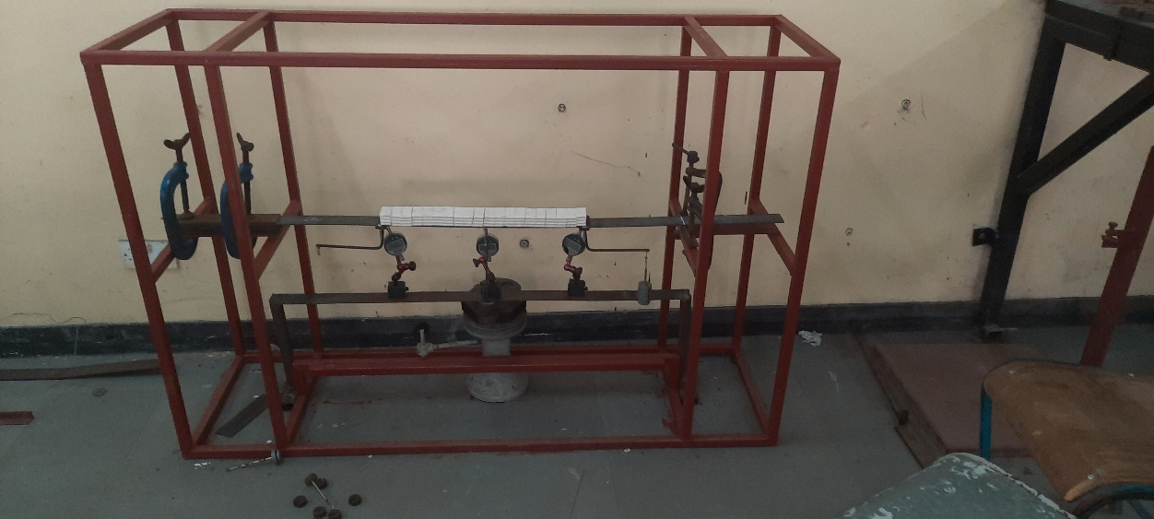

Figure 16: a set up for experiment 3

**At x = ¼l**

Y =

Table 9: tabulated results for experiment 3 at x =

|  |  |  |  |  |  |  |  |
| --- | --- | --- | --- | --- | --- | --- | --- |
| Load (g) | 0 | 50 | 100 | 150 | 200 | 250 | 300 |
| 1st reading(mm) | 1.59 | 1.78 | 2.01 | 2.27 | 2.52 | 2.73 | 3.04 |
| 2nd reading(mm) | 1.64 | 1.96 | 2.06 | 2.28 | 2.53 | 2.77 | 3.04 |
| 3rd reading(mm) | 1.63 | 1.84 | 2.05 | 2.29 | 2.53 | 2.75 | 3.01 |
| Average(mm) | 1.62 | 1.86 | 2.04 | 2.28 | 2.52 | 2.75 | 3.01 |
| Theoretical(mm) | 1.37 | 1.60 | 1.81 | 2.03 | 2.25 | 2.47 | 2.69 |
| Deviation | -0.25 | -0.26 | -0.23 | -0.25 | -0.27 | -0.28 | -0.32 |
| % deviation | 18.24 | 16.25 | 12.71 | 12.31 | 12 | 11.33 | 11.89 |

**At x = ½l**

Y =

Table 10: tabulated results for experiment 3 at x =

|  |  |  |  |  |  |  |  |
| --- | --- | --- | --- | --- | --- | --- | --- |
| Load (g) | 0 | 50 | 100 | 150 | 200 | 250 | 300 |
| 1st reading(mm) | 3.35 | 3.72 | 4.16 | 4.59 | 5.09 | 5.55 | 6.10 |
| 2nd reading(mm) | 3.33 | 3.72 | 4.17 | 4.61 | 5.09 | 5.53 | 6.06 |
| 3rd reading(mm) | 3.19 | 3.57 | 4.05 | 4.49 | 5.11 | 5.51 | 6.09 |
| Average(mm) | 3.29 | 3.67 | 4.12 | 4.56 | 5.09 | 5.53 | 6.08 |
| Theoretical(mm) | 2.97 | 3.44 | 3.91 | 4.38 | 4.85 | 5.32 | 5.79 |
| Deviation | -0.32 | -0.23 | -0.21 | -0.24 | -0.24 | -0.21 | -0.29 |
| % deviation | 10.77 | 6.68 | 5.37 | 5.47 | 4.94 | 3.94 | 5.06 |

**At x = ¾l**

Y =

Table 11: tabulated results for experiment 3 at x =

|  |  |  |  |  |  |  |  |
| --- | --- | --- | --- | --- | --- | --- | --- |
| Load (g) | 0 | 50 | 100 | 150 | 200 | 250 | 300 |
| 1st reading(mm) | 2.64 | 2.99 | 3.43 | 3.82 | 4.38 | 4.74 | 5.27 |
| 2nd reading(mm) | 2.73 | 3.13 | 3.50 | 3.92 | 4.36 | 4.76 | 5.28 |
| 3rd reading(mm) | 2.72 | 3.09 | 3.50 | 3.89 | 4.36 | 4.77 | 5.24 |
| Average(mm) | 2.69 | 3.06 | 3.47 | 3.87 | 4.36 | 4.75 | 5.26 |
| Theoretical(mm) | 2.40 | 2.79 | 3.19 | 3.59 | 3.99 | 4.39 | 4.79 |
| Deviation | -0.29 | -0.27 | -0.28 | -0.28 | -0.37 | -0.36 | -0.47 |
| % deviation | 12.08 | 9.67 | 8.77 | 7.79 | 9.27 | 8.2 | 9.59 |

**4.2.4 EXPERIMENT 4**

P

P

l/4

l/4

l/4

P

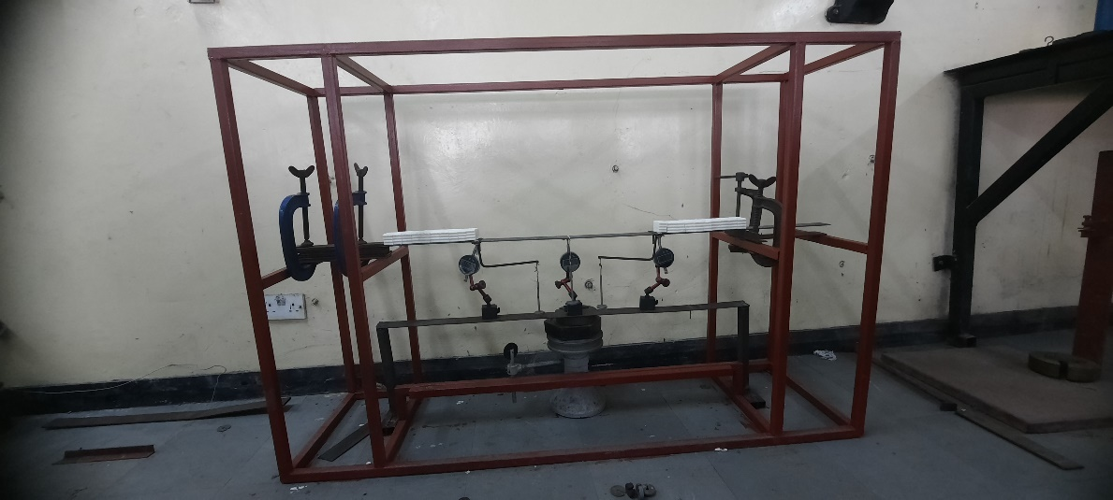

Figure 17: set up for experiment 4

**At x = ¼**

Y =

Table12: tabulated results for experiment 4 at x =

|  |  |  |  |  |  |  |  |
| --- | --- | --- | --- | --- | --- | --- | --- |
| Load (g) | 0 | 50 | 100 | 150 | 200 | 250 | 300 |
| 1st reading(mm) | 0.64 | 0.87 | 1.19 | 1.55 | 1.88 | 2.13 | 2.36 |
| 2nd reading(mm) | 0.63 | 0.92 | 1.22 | 1.56 | 1.86 | 2.13 | 2.37 |
| 3rd reading(mm) | 0.65 | 0.94 | 1.25 | 1.58 | 1.84 | 2.12 | 2.36 |
| Average(mm) | 0.64 | 0.91 | 1.22 | 1.56 | 1.86 | 2.12 | 2.36 |
| Theoretical | 2.42 | 2.69 | 2.96 | 3.23 | 3.50 | 3.79 | 4.04 |
| Deviation | 1.78 | 1.78 | 1.74 | 1.67 | 1.64 | 1.67 | 1.68 |
| % deviation | 73.55 | 66.17 | 58.78 | 51.70 | 46.85 | 44.06 | 41.58 |

**At x = ½ l**

y =

Table 13: tabulated results for experiment 4 at x =

|  |  |  |  |  |  |  |  |
| --- | --- | --- | --- | --- | --- | --- | --- |
| Load (g) | 0 | 50 | 100 | 150 | 200 | 250 | 300 |
| 1st reading(mm) | 1.04 | 1.57 | 2.22 | 2.77 | 3.48 | 3.98 | 4.47 |
| 2nd reading(mm) | 1.06 | 1.63 | 2.24 | 2.89 | 3.48 | 4.01 | 4.46 |
| 3rd reading(mm) | 1.05 | 1.66 | 2.29 | 2.95 | 3.46 | 4.02 | 4.46 |
| Average(mm) | 1.05 | 1.62 | 2.25 | 2.87 | 3.47 | 4.00 | 4.46 |
| Theoretical | 6.18 | 6.77 | 7.33 | 7.90 | 8.48 | 9.05 | 9.62 |
| Deviation | 5.13 | 5.15 | 5.08 | 5.03 | 5.01 | 5.05 | 5.16 |
| % deviation | 83.00 | 76.07 | 69.30 | 63.67 | 59.08 | 55.80 | 53.36 |

**At x = ¾**

Y =

Table 14: tabulated results for experiment 4 at x =

|  |  |  |  |  |  |  |  |
| --- | --- | --- | --- | --- | --- | --- | --- |
| Load (g) | 0 | 50 | 100 | 150 | 200 | 250 | 300 |
| 1st reading(mm) | 0.76 | 1.22 | 1.63 | 1.93 | 2.55 | 2.92 | 3.20 |
| 2nd reading(mm) | 0.75 | 1.20 | 1.67 | 2.14 | 2.57 | 2.92 | 3.20 |
| 3rd reading(mm) | 0.75 | 1.15 | 1.71 | 2.19 | 2.55 | 2.92 | 3.21 |
| Average(mm) | 0.75 | 1.19 | 1.67 | 2.08 | 2.55 | 2.92 | 3.20 |
| Theoretical | 6.78 | 7.24 | 7.70 | 8.16 | 8.63 | 9.08 | 9.52 |
| Deviation | 6.03 | 6.05 | 6.03 | 6.08 | 6.08 | 6.16 | 6.32 |
| % deviation | 88.93 | 83.56 | 78.31 | 74.50 | 70.45 | 67.84 | 66.38 |

**4.2.5 EXPERIMENT 5**

l/4

l/4

l/4

l/44

2Pe

Pe

2Pe

P

2P

2P

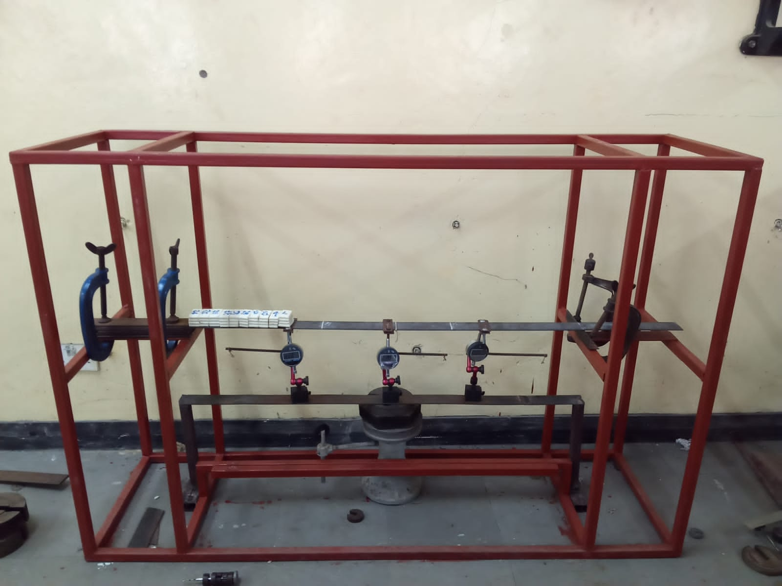

Figure 18: set up for experiment 5

**At x = ¼**

y =

Table 15: tabulated results for experiment 5 at x =

|  |  |  |  |  |  |  |  |
| --- | --- | --- | --- | --- | --- | --- | --- |
| Load (g) | 0 | 50 | 100 | 150 | 200 | 250 | 300 |
| 1st reading(mm) | 0.20 | 0.36 | 0.62 | 0.88 | 1.02 | 1.29 | 1.47 |
| 2nd reading(mm) | 0.22 | 0.44 | 0.69 | 0.89 | 1.03 | 1.28 | 1.59 |
| 3rd reading(mm) | 0.22 | 0.48 | 0.69 | 0.89 | 1.04 | 1.44 | 1.72 |
| Average(mm) | 0.21 | 0.42 | 0.66 | 0.88 | 1.03 | 1.33 | 1.59 |
| Theoretical(mm) | 0.21 | 0.44 | 0.68 | 0.92 | 1.16 | 1.41 | 1.65 |
| Deviation | 0 | 0.01 | 0.02 | 0.04 | 0.13 | 0.08 | 0.06 |
| % deviation | 0 | 2.27 | 2.94 | 4.34 | 11.20 | 5.67 | 3.63 |

**At x = ½ l**

y =

Table 16: tabulated results for experiment 5 at x =

|  |  |  |  |  |  |  |  |
| --- | --- | --- | --- | --- | --- | --- | --- |
| Load (g) | 0 | 50 | 100 | 150 | 200 | 250 | 300 |
| 1st reading(mm) | 0.20 | 0.83 | 1.34 | 2.02 | 2.72 | 3.39 | 3.92 |
| 2nd reading(mm) | 0.21 | 0.88 | 1.36 | 2.09 | 2.92 | 3.42 | 4.08 |
| 3rd reading(mm) | 0.24 | 0.81 | 1.32 | 2.09 | 2.91 | 3.64 | 4.57 |
| Average(mm) | 0.22 | 0.84 | 1.34 | 2.05 | 2.85 | 3.48 | 4.19 |
| Theoretical(mm) | 0.27 | 0.87 | 1.47 | 2.07 | 2.67 | 3.27 | 3.87 |
| Deviation | 0.05 | 0.03 | 0.13 | 0.02 | -0.18 | -0.21 | -0.32 |
| % deviation | 18.51 | 3.44 | 8.84 | 0.96 | 6.74 | 6.42 | 8.26 |

**At x = ¾ l**

y =

Table 17: tabulated results for experiment 5 at x = ¾

|  |  |  |  |  |  |  |  |
| --- | --- | --- | --- | --- | --- | --- | --- |
| Load(g) | 0 | 50 | 100 | 150 | 200 | 250 | 300 |
| 1st reading(mm) | 0.23 | 0.80 | 1.38 | 1.95 | 2.58 | 3.28 | 3.83 |
| 2nd reading(mm) | 0.22 | 0.77 | 1.36 | 2.01 | 2.58 | 3.31 | 3.90 |
| 3rd reading(mm) | 0.20 | 0.76 | 1.41 | 2.02 | 2.65 | 3.28 | 4.06 |
| Average(mm) | 0.21 | 0.77 | 1.38 | 1.99 | 2.60 | 3.29 | 3.93 |
| Theoretical(mm) | 0.18 | 0.76 | 1.34 | 1.92 | 2.50 | 3.08 | 3.66 |
| Deviation | -0.03 | -0.01 | -0.04 | -0.07 | -0.1 | -0.21 | -0.27 |
| % deviation | 16.66 | 1.32 | 2.98 | 3.64 | 4.00 | 6.81 | 7.37 |

**4.3 DISCUSSION OF RESULTS**

The first two results were done to obtain Young’s Modulus of Elasticity of our beam specimen. The two deflection experiments gave the value of E ranging from 202 and 208 Gpa. The closeness of these two values shows that we were able to achieve the end conditions for our project. An average was calculated and it was maintained throughout the experiment and used to calculate theoretical deflections.

The percentage deviations were averagely below 20%.

**4.4 SOURCES OF ERRORS**

1. The major source of error came from the use of the dial gauge indicator, the DTI had zero drift which we believe in some ways contributed to the deviation from the theoretical results.
2. Systematic errors also occurred as a result of failure to account for factors such as vibrations and changes in temperature.
3. Subjecting the beam specimen to huge loads continuously caused bending and thus the end conditions were not suitable to get as accurate values as possible
4. Misalignment of the testing rig
5. Parallax error- this is due to the misalignment of the eye to the pointer.

**CHAPTER 5**

**5.0 CONCLUSION**

The experiments from the simply supported and both ends fixed beams done before gave values of the Young’s Modulus of Elasticity that are within the acceptable range. This proved that we were able to achieve the end conditions for our beam specimen.

The comparison between the theoretical and the experimental results had a small deviation that were acceptable due to the sources of the errors stated. The aim of the experiment was to verify whether the theoretical values calculated, with the various loadings on the beam that is one end fixed and one end propped is close in value when done experimentally. From the analyzed results, we can agree. Our objectives were met since there was a close resemblance between the theoretical and the experimental results.

The analyzed results further implied that the design and the loadings were done correctly.

**5.1 RECOMMENDATIONS**

a) The overall mass of the soap should be small, maybe a bar soap of 700g. A higher mass results in the deformation of the beam thus contributing to larger errors.

b) The rig structure should be placed in a flat surface in a room with little to no activity. This is because any sort of vibration alters the values that will be shown.

c) Before conducting any experiment on the deflection of beams, a separate experiment should be done to first ascertain if the end conditions are met. The value of Young’s Modulus of Elasticity should be obtained experimentally.

d) The mass of the pieces of soap should be taken before any experiment is done. This is because the pieces lose weight when exposed to air.

e) The type and material of the beam to be used should be chosen carefully. Some are not as strong and thus bend easily.

f) At the start of a new experiment, a new beam may be required to get accurate results.

**5.2 REFERENCES**

Case, J. (1998). Strength of Materials. New York: John Wiley and sons.

Crawford, P.B (1987). Mechanics of Engineering Materials (2nd Edition ed.). Singapore: Longman Singapore Publishers.

Goodno, J. M. (2009). Mechanics of materials (7th edition). Stamford: Cengage Learning.

**APPENDIX**

**LABORATORY MANUAL**

TITLE

Deflection of one end fixed and one end propped beams under pure couple, uniformly distributed load and a point load.

OBJECTIVES

To verify whether the experimental values of deflections of beams are same or close to the the theoretical values calculated.

APPARATUS

1. A simple universal testing rig.
2. Vernier calipers. This will be used to measure the width and thickness of the beam.
3. Dial gauge indicator. This will be used to measure deflection of the beam.
4. Tape measure. This will be used to measure the length of the test region.
5. Metallic beam. It should be fairly rectangular, thin and long. Specific dimensions are dependent to the size of the test frame and available weights.
6. Chalk.
7. 2 bars of soap.
8. Frictionless string.

THEORY

This is a beam fixed on one end and the other is simply supported. The fixed end condition is obtained by fastening the beam between two metal parking and two G-clamps therefore the condition at this end are zero deflection and slope at this end is zero. On the propped end, the deflection is zero but the slope is not equal to zero

PROCEDURE AND EXPERIMENTAL SETUP

1. Let the length of the beam be 100cm
2. Measure out distances from left hand side,
3. Fix two couple attachments at the and marks and tie the frictionless string on them.
4. Measure out ¼ distances throughout the beam, mark out ¼, ½, ¾,from left hand side.
5. Mount the beam firmly on the rig. The left-hand side should have two metal parking fasteners with two G-clamps and let the other end rest freely on the metal rig.
6. Place dial gauges at ¼ and ½, set the gauges to read zero with no load applied.
7. Cut the bar of soap into 2.5 cm each and weigh each piece. The total weight used will be converted to newtons and divided by the distance it covers to get (w).
8. Load the soap at the beam slowly.
9. Place masses at the couple attachments at the string hanging. Record the new readings from the gauges.
10. Add masses in the interval of 50 grams on every mass hanger and record and the readings for every mass added. (3 readings and their average should be recorded for every mass added).
11. The theoretical deflection is calculated by using the Macaulay’s Methods.
12. The comparison is done with the theoretical and actual deflections and percentage deviation is calculated.

|  |  |  |  |  |  |  |  |
| --- | --- | --- | --- | --- | --- | --- | --- |
| Load(g) | 0 | 50 | 100 | 150 | 200 | 250 | 300 |
| 1st reading(mm) |  |  |  |  |  |  |  |
| 2nd reading (mm) |  |  |  |  |  |  |  |
| 3rd reading (mm) |  |  |  |  |  |  |  |
| Average (mm) |  |  |  |  |  |  |  |
| Theoretical (mm) |  |  |  |  |  |  |  |
| Deviation |  |  |  |  |  |  |  |
| % deviation |  |  |  |  |  |  |  |